Code Smells – Ana Gadelha 59943

Class Location:
ganttproject/src/main/java/net/sourceforge/ganttproject/action/project/CloudProjectActionBase.java
This class is Dead Code because it is never used, it should be removed, to simplify the code and reduce the code size.
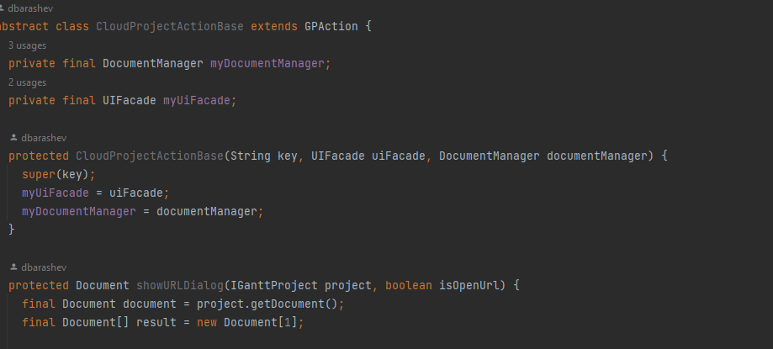

Class Location:
ganttproject/src/main/java/net/sourceforge/ganttproject/chart/gantt/GanttChartController.java
This constructor has too many arguments, what can indicate that this class has more functionalities than what it should have.
A way to make it simpler would be to aggregate some of the arguments into a class, and then the constructor would only have to receive one argument instead of receiving them individually.
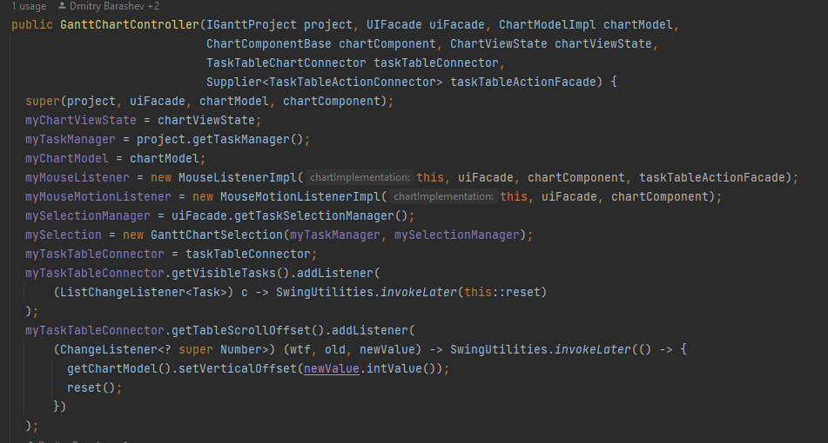

Class Location:
ganttproject/src/main/java/net/sourceforge/ganttproject/chart/ChartModelImpl.java
This class has a lot of unnecessary comments, what can be confusing, and also mean that the method is too complex what causes the need to exaggerate on the comments.
A solution to this would be to remove the unnecessary comments and simplify the method so tat it does not need such an explanation.
